Computer Graphic Assignment 3

Yixin Yin

I write 2 versions of the assignment. It contains the file “Assignment 3 basic requirement” and the file “assignment3 do more”.

The “Assignment3 basic requirement” realizes all the basic requirements. All the keyboard functions are working. But the rotate and translate are related to the world coordinates. It is not intuitive.

The “Assignment3 do more” realize all the basic requirements. In addition, I make the viewing intuitive. I realize the higher requirement 1 and 4 list at blackboard. So all the translations and rotations are related to the view plane. However you rotate or translate, left is always left, right always right, rotation down is always rotation down. It is realized by following way.

Write the following in the keyboard function

glMatrixMode(GL_MODELVIEW);

glLoadIdentity();

glMultMatrixf(g_rot_matrix);

glGetFloatv(GL_MODELVIEW_MATRIX, g_rot_matrix);

Then I substitute the rotation function with the accumulated rotation function. Write the following in the draw_scene function.

glMultMatrixf(g_rot_matrix);

for the intuitive viewing translation. I use the direction vector and move the car according to the direction vector (g_view_dir).

Here is a simple example.

Initial:

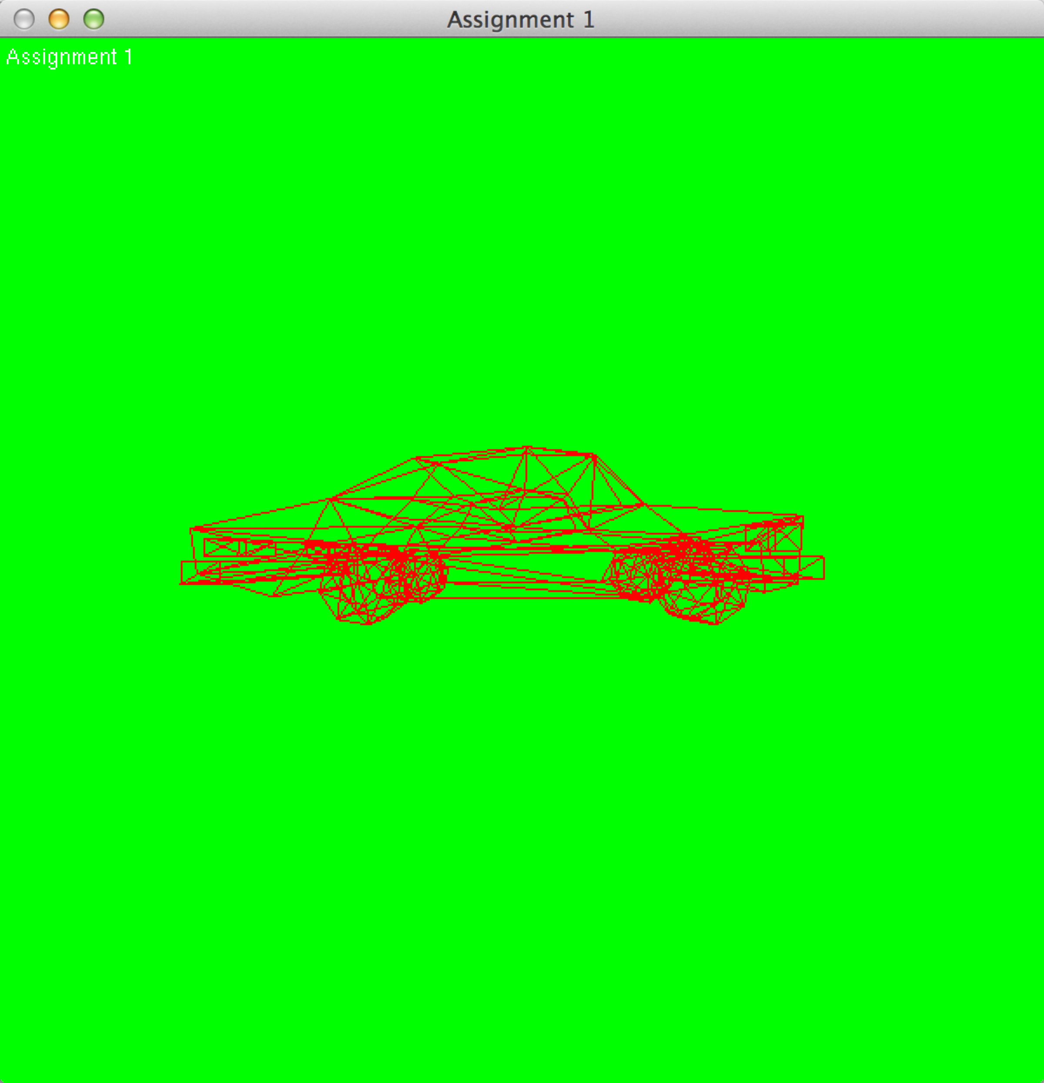

In the basic requirement, if I rotate the car using “i” like that:

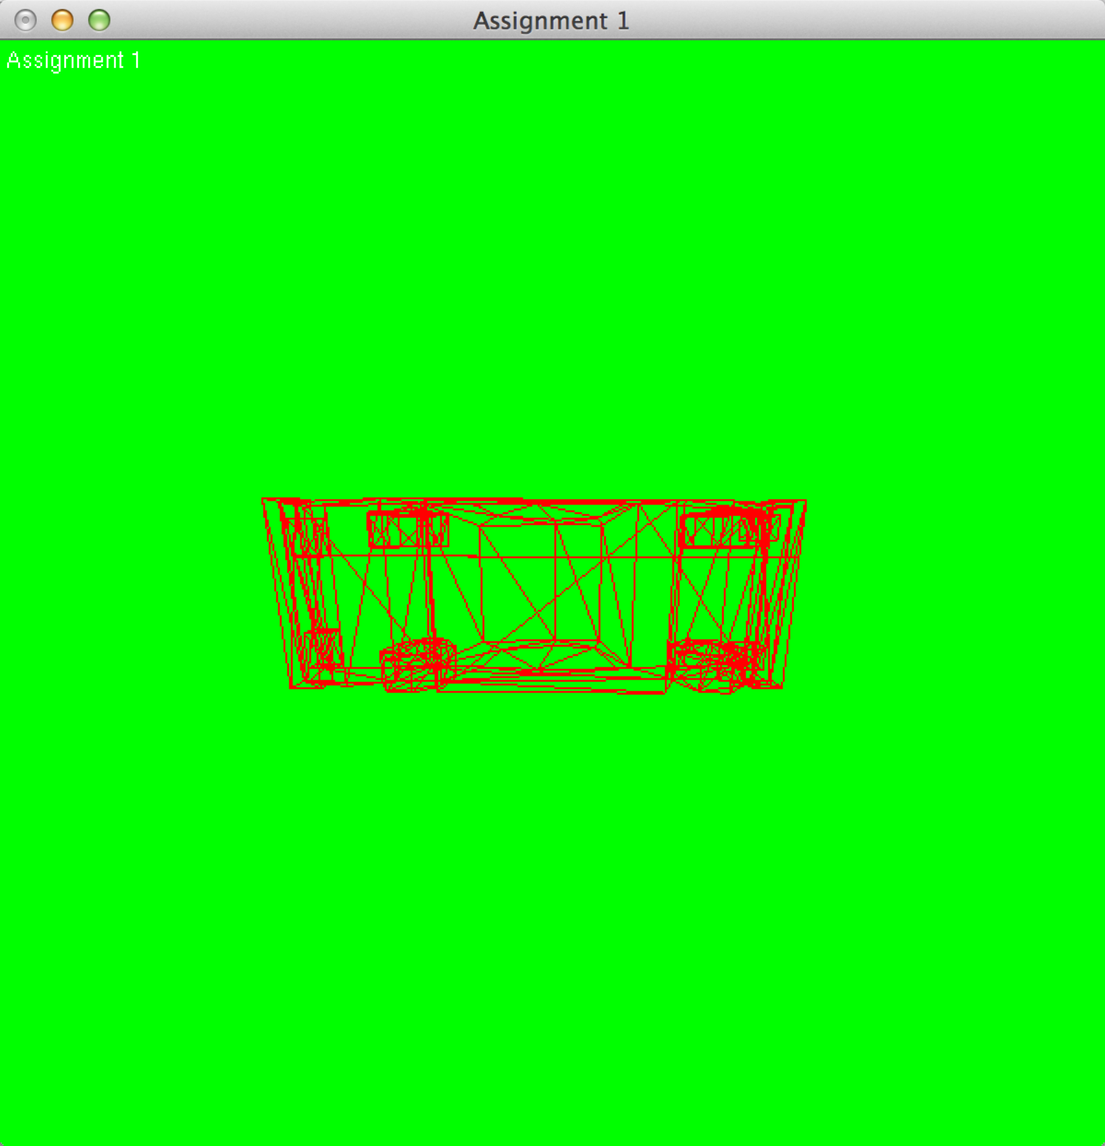

then I press “j” it will rotate like that:

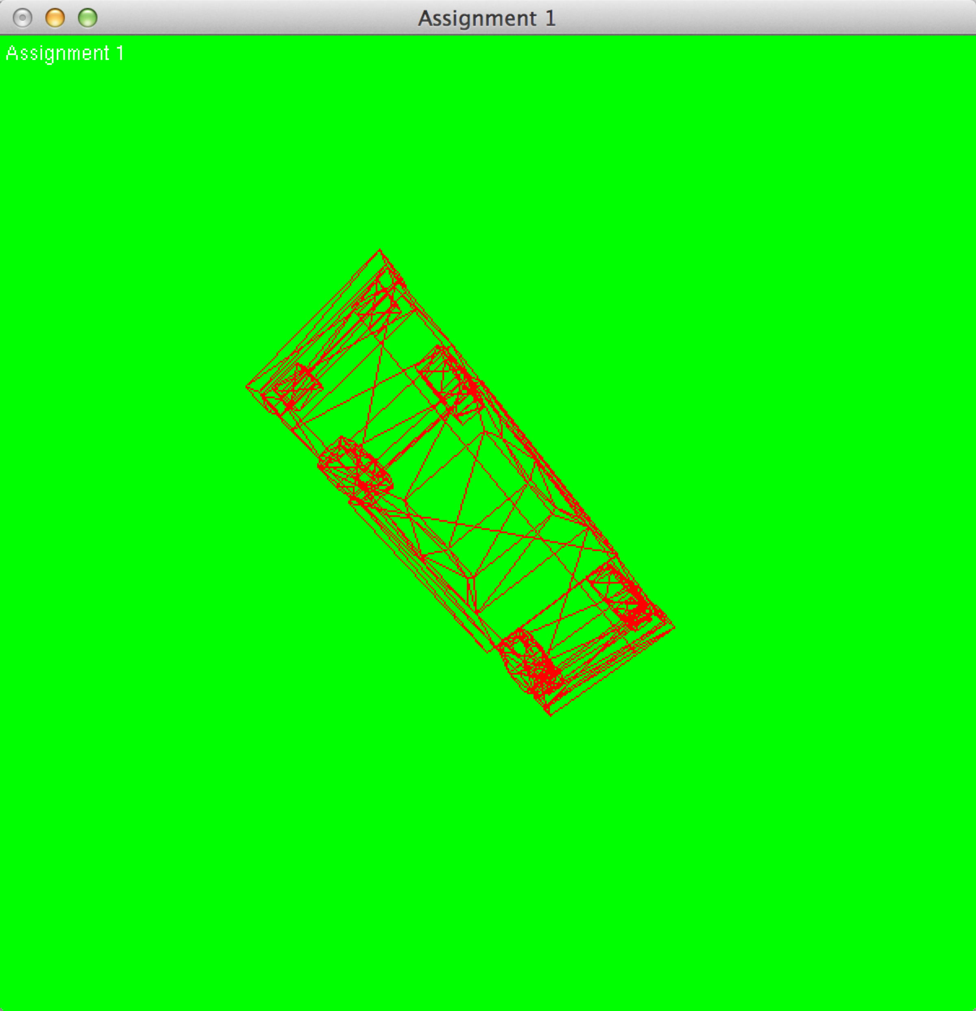

it is not intuitive, it only rotate according to the world coordinates.

The following are higher requirements.

Initial:  
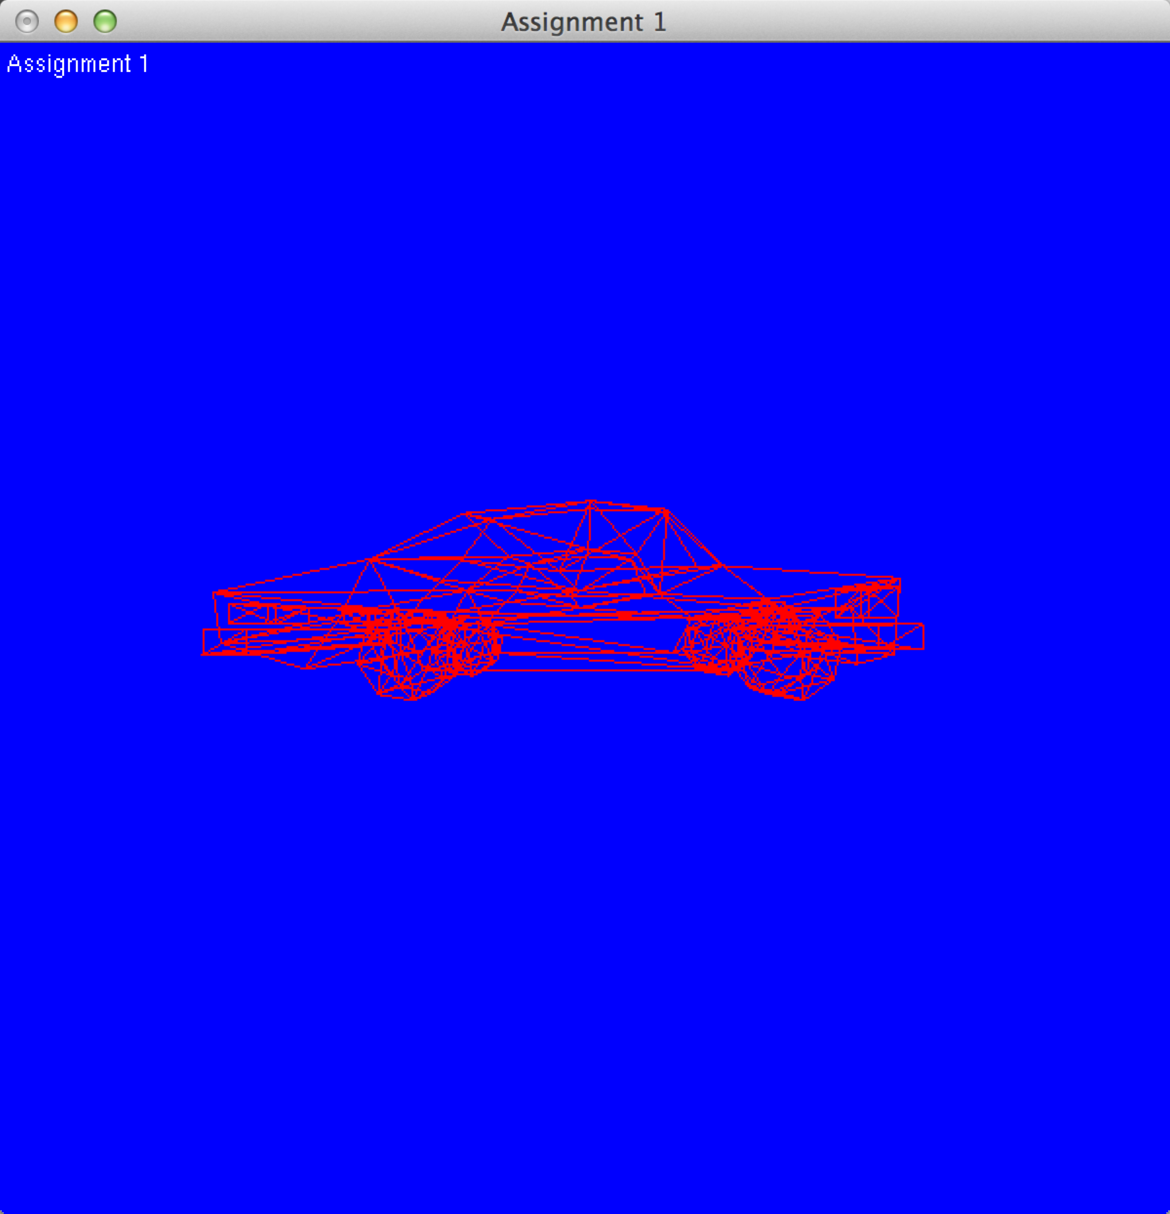

I press “i” and rotate like the basic one.

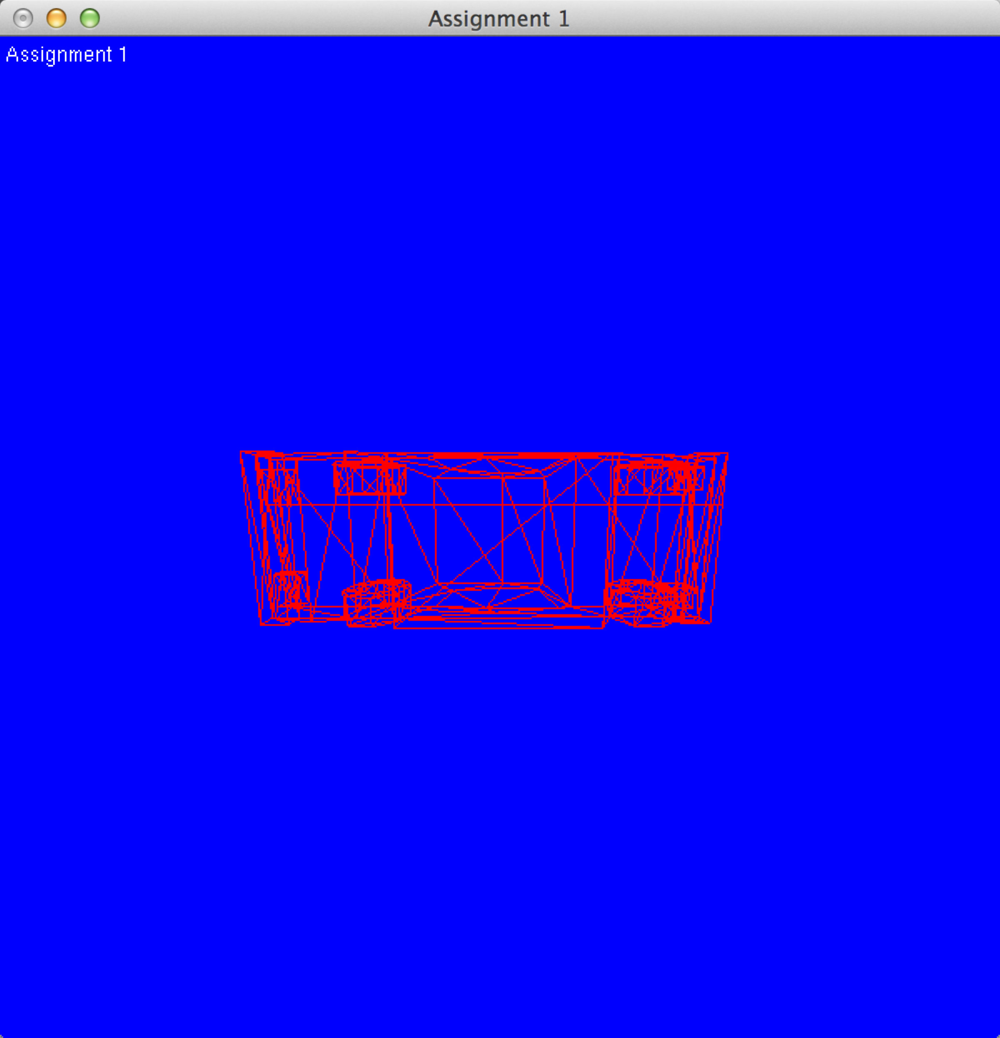

Then I press “j”, it will like the following:  
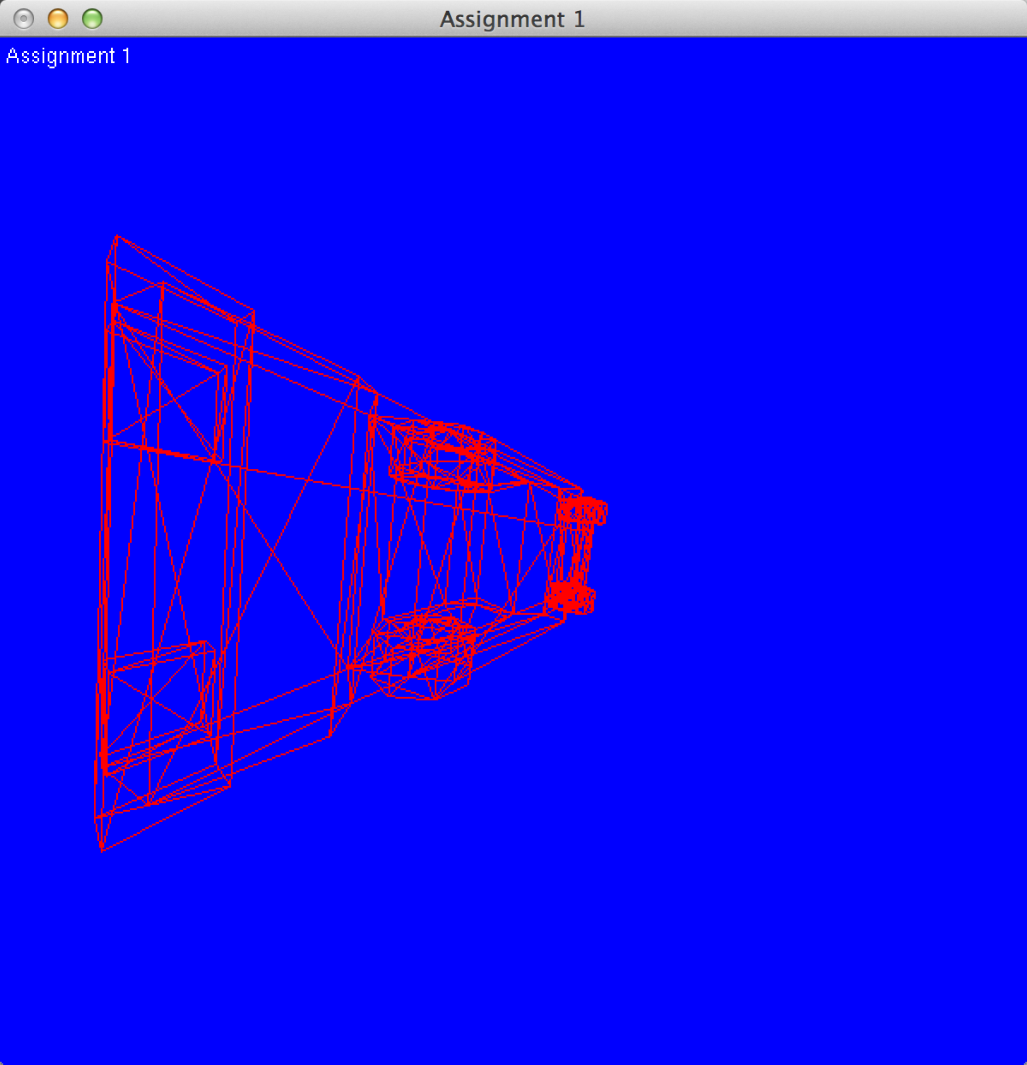

It rotates according to the view plane and is accumulated.

Those are all the implements. Thanks.

I do not realize the higher requirement 2 and 3. The followings are requirement 1 and 4.

1.Make sure subsequent rotations rotate the object intuitively.  Rotating the object downward should rotate downward relative to your viewing position even if you have already rotated the object on the y-axis.

4.When you move around the object (via keyboard (w,a,s,d) and left-right arrows), make it so that when you translate or rotate the object from your new position, the object translates and rotates in the correct direction relative to your new  position.  So if you rotate 'down' (via keyboard or mouse), the model should rotate down about an axis that is perpendicular to your viewing direction. This means that the axis of rotation should be transformed by the viewing matrix.